Football Player Market Value Prediction System

1. Executive Summary
This document presents the design and implementation of an end-to-end machine learning system developed to predict the market value of professional football players. The system consolidates data from multiple football and social media sources, including player performance, injury history, transfer activity, contract information, and public sentiment, to create a comprehensive and data-driven valuation framework.
The solution follows a robust and structured machine learning pipeline, covering data integration, cleaning, feature engineering, and model development. Multiple regression models were evaluated through a progressive modeling strategy, leading to the selection of a LightGBM-based approach for its strong predictive accuracy, stability, and ability to capture complex non-linear relationships. Special emphasis was placed on data integrity through strict target leakage prevention, scalable encoding strategies, and numerically stable feature transformations.The final model is deployed through a user-friendly web interface, allowing stakeholders to interact with the system and obtain reliable market value estimates without requiring technical expertise.
Overall, this project delivers a production-ready, interpretable, and scalable player valuation system that supports informed decision-making in the football transfer market and demonstrates best practices in applied machine learning and software engineering.

2. Problem Statement and Motivation

2.1 Problem Statement
The global football transfer market is a multi-billion dollar industry where accurate player valuation is a cornerstone of strategic decision-making for clubs, agents, and stakeholders. A player's economic worth is determined by a complex and dynamic interplay of factors, including on-field performance, age, contract status, physical condition, and public perception. This multi-faceted landscape makes valuation a challenging and high-stakes prediction problem.The central challenge addressed by this project is the need to move beyond traditional subjective assessments and establish a data-driven, systematic framework for player valuation.
There is a clear need for a systematic, data-driven solution that can evaluate players using a unified and objective framework, reduce bias in valuation, and provide consistent decision support across different stakeholders.

2.2 Motivation
The motivation behind this system is to move beyond traditional valuation methods and build a scalable machine learning solution that reflects how modern football markets operate. A player’s market value is not determined by a single factor but by a complex interaction between on-field performance, career trajectory, physical reliability, contract conditions, and public perception.
Equally important, the system is designed as a decision-support product, not a black-box replacement for expert judgment. Transparency, explainability, and production readiness were treated as core requirements to ensure that the model’s outputs can be trusted and effectively used in practical scenarios.

3. System Objectives
The primary objectives of the system are as follows:
The system aims to predict the market value of professional football players using historical, contextual, and behavioral data in a consistent and reproducible manner. It is designed to integrate performance metrics, injury history, transfer activity, contract information, and sentiment signals into a unified valuation framework that reflects real-world football economics.
A key objective is to ensure that all predictions are interpretable and explainable, allowing stakeholders to understand not only the predicted value but also the contributing factors behind each prediction. This transparency is essential for trust and adoption in high-stakes decision environments.
From an engineering perspective, the system is designed to be scalable, modular, and deployable in real-world environments. It supports clean separation between data processing, modeling, and deployment layers, enabling maintainability, monitoring, and future enhancements.
Overall, the system functions as a decision-support tool, assisting analysts, scouts, and stakeholders with data-backed insights while preserving human oversight and expertise.
4. System Architecture

4.1 Architectural Overview
The system follows a modular, pipeline-driven architecture aligned with standard machine learning product design principles. Each layer of the architecture is independently verifiable and designed to support scalability, traceability, and reproducibility.

The architecture can be broadly divided into five layers:
- Data Sources
- Data Layer
- Modeling Layer
- Prediction Layer
- Deployment and Monitoring Layer
This layered design ensures a clean separation of concerns and minimizes coupling between components.

4.2 Architecture Description
Data Sources Layer
The system ingests data from multiple independent sources, including contract information, injury reports, transfer history, match data, player statistics, and social media sentiment. These sources collectively capture both objective performance metrics and contextual market signals.
Data Layer
The data layer is responsible for collecting, cleaning, and integrating raw data into a player-level representation. This includes standardizing formats, resolving inconsistencies, aggregating event-level data, and generating engineered features. The output of this layer is stored in a centralized feature store to ensure consistent access during both training and inference.
Modeling Layer
The modeling layer consumes features from the feature store and applies multiple specialized models, including performance-based models and sentiment-aware models. These components feed into a consolidated market value prediction model that captures non-linear interactions between different feature groups.
Prediction Layer
The prediction layer handles real-time inference. It generates market value predictions, computes confidence estimates, and invokes the explainability engine to provide feature-level reasoning for each prediction.
Deployment and Monitoring Layer
This layer exposes the system through an API and web-based dashboard. It also supports continuous monitoring and a feedback loop to track system performance, detect drift, and support retraining workflows.
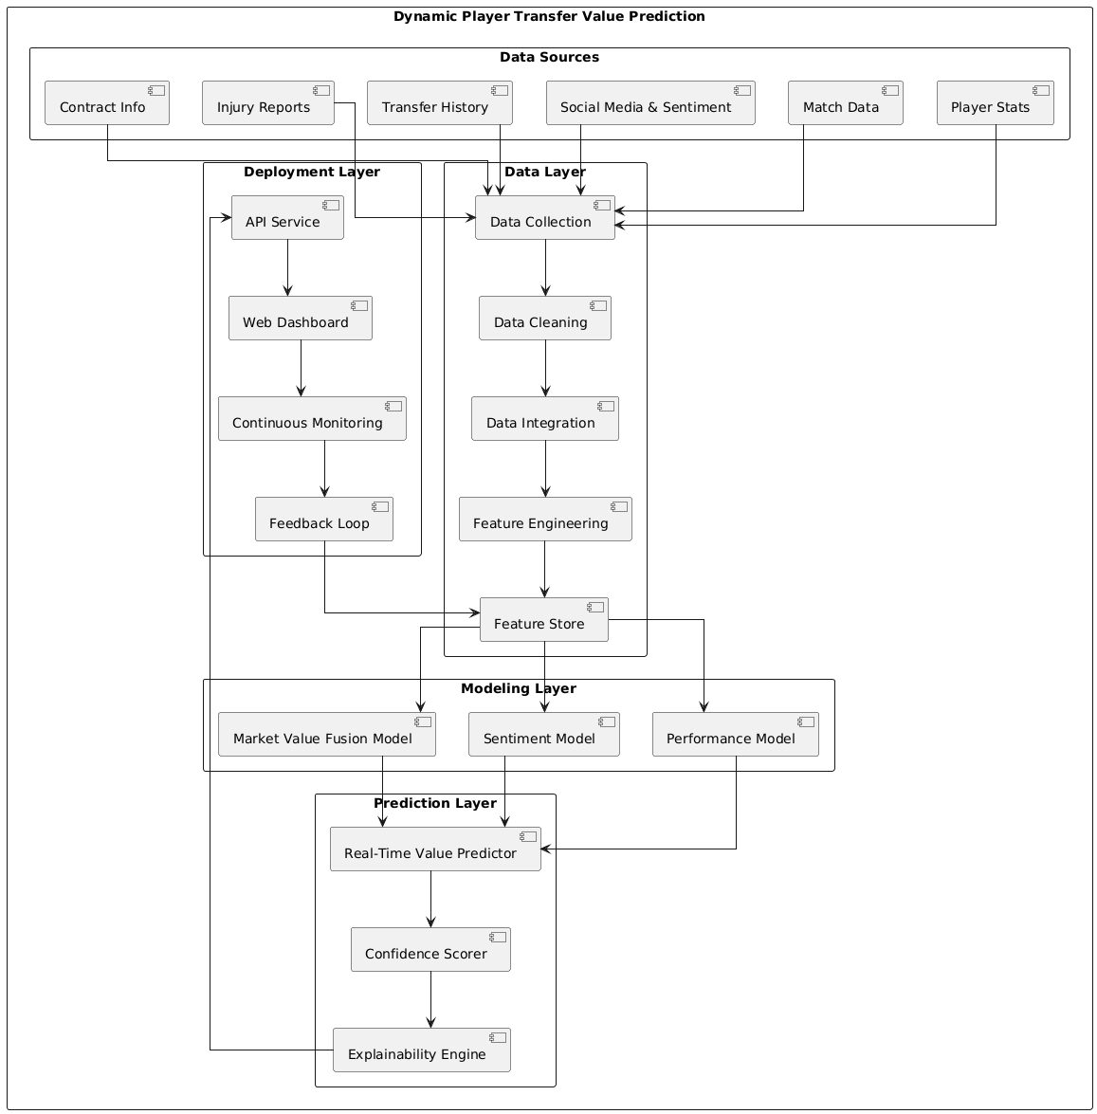
Figure 1: End-to-End System Architecture for Dynamic Player Market Value Prediction

5. Software Requirements Specification (SRS)

5.1 Functional Requirements
a) The system shall ingest and process data from multiple football-related sources, including performance data, injury reports, transfer history, contract information, and social media sentiment data.
b) The system shall clean, normalize, and integrate raw data into a unified, player-level dataset suitable for machine learning and analytical processing.
c) The system shall generate engineered features that capture player performance trends, injury risk, contract and transfer dynamics, and sentiment-based public perception signals.
d) The system shall predict player market value using a trained machine learning model based on historical and contextual data.
e) The system shall provide explainability for each prediction through an interpretable framework, enabling users to understand the factors influencing the predicted value.
f) The system shall expose prediction results through a user-facing web interface and a programmatic API to support interactive and automated usage.
g) The system shall support monitoring and feedback collection to enable ongoing evaluation of model performance and system behavior.

5.2 Non-Functional Requirements
a) The system shall ensure consistency between training and inference environments to prevent training–serving skew.
b) The system shall be scalable to handle large datasets and support the integration of additional data sources in the future.
c) The system shall provide reliable and repeatable predictions across multiple sessions and deployment instances.
d) The system shall maintain acceptable inference latency to support interactive user requests in real-time or near real-time scenarios.
e) The system shall ensure transparency and traceability of predictions, allowing stakeholders to audit model behavior and decision logic.

5.3 System Constraints and Assumptions
a) The system relies on historical data and may not immediately reflect sudden market changes such as unexpected transfers, injuries, or external economic factors.
b) Prediction quality is dependent on data availability; players with limited historical records may exhibit higher uncertainty in predicted market value.
c) Sentiment-based features are inherently noisy and are treated as supplementary signals rather than primary drivers of valuation decisions.

6. Data Sources and Integration
A reliable player valuation system depends fundamentally on the quality, diversity, and completeness of its underlying data. To capture the multi-dimensional nature of football player market value, the system aggregates information from a wide range of independent sources, each representing a different aspect of a player’s career, performance, and market perception.
In order to complete this project, three sources of data were identified: -
- Player Performance Data: StatsBomb Open Data
- Market Value Data: Transfermarkt datascrapping
- Social Media Sentiment: Twitter API for sentiment analysis of player mentions.
In total, data from 11 independent datasets was integrated to construct a unified player profile for over 92,000 unique players. These datasets were deliberately selected to ensure that both quantitative performance indicators and contextual market signals were represented in the valuation framework.
The data sources span four primary domains. Performance-related data includes detailed match-level statistics such as goals, assists, and minutes played, along with team- and competition-level context and teammate interaction metrics. Career and transfer data captures player profiles, demographic attributes, complete transfer histories with associated fees and dates, historical and latest market value records, contract duration and expiry details, and national team appearances. Physical condition data provides a detailed view of injury history, including injury frequency, duration, recurrence, and total days missed. In addition, sentiment and public perception data was incorporated through social media sources, enabling the extraction of sentiment polarity, confidence scores, and temporal sentiment variability.
Individually, each dataset provides a partial view of a player’s value. Combined, they form a comprehensive representation of both on-field contribution and off-field market dynamics. The integration of these diverse data sources established a single, cohesive foundation for all downstream processing and modeling activities.

6.1 Data Integration Strategy
The primary technical challenge during integration was the heterogeneous and event-driven nature of the source data. Most datasets contained multiple records per player, such as match-by-match performance logs, repeated injury events, multiple transfers, and time-stamped market value entries. A naive merge of these datasets resulted in severe row duplication, producing a dataset with over 900,000 rows, which was unsuitable for machine learning and introduced bias toward players with more recorded events.
Directly merging these datasets resulted in excessive row duplication, making the data unsuitable for machine learning.
To address this, a player-centric integration strategy was adopted:
- Each dataset was aggregated to the player level
- Unique player identifiers were used as the primary key
- Event-level data was summarized into meaningful player-level metrics
This ensured that:
- Each player is represented by exactly one row
- Features reflect cumulative and contextual career information
- Bias from players with more recorded events is avoided

6.2 Player-Level Aggregation Logic
Event-based datasets were transformed using aggregation techniques tailored to the nature of each data source.
Key aggregation approaches included:

- Summation: Total goals, assists, minutes played
- Averaging: Per-90 performance metrics
- Temporal Derivation: Years since last transfer, age, contract duration
- Trend Extraction: Market value growth and variability
- Count-Based Metrics: Injury frequency, transfer count, tweet volume
This aggregation step reduced the dataset from over 900,000 event-level rows to approximately 92,000 player-level records, forming a clean and structured dataset ready for feature engineering.

7. Sentiment Analysis Methodology
Once the data from all sources was integrated, the primary focus shifted to making the dataset reliable, consistent, and safe for downstream modeling. The raw merged data contained a mix of irrelevant metadata, inconsistent formats, and missing values that, if left untreated, would have introduced noise and instability into the system.
The cleaning process began with a systematic assessment of feature relevance. Fields that provided no predictive value—such as image URLs, external links, and auxiliary metadata—were removed to reduce dimensionality and improve processing efficiency. Columns with extreme sparsity were also excluded, as their presence would not meaningfully contribute to prediction quality.
Numerical fields were standardized to ensure consistent behavior during aggregation and modeling. Special attention was given to ensuring that cumulative metrics, such as goals, assists, and minutes played, were numerically stable and free from type inconsistencies. In parallel, all categorical attributes were normalized to ensure consistent representations across datasets.
Temporal consistency was critical for this system. Date and season fields appeared in multiple formats due to differing data sources. These were normalized into a unified datetime representation, enabling accurate computation of derived features such as player age, contract duration, and transfer recency. This preprocessing stage established a stable foundation, ensuring that all subsequent feature engineering and modeling steps operated on clean and well-structured data.

7. Data Cleaning and Preprocessing
Once the data from all sources was integrated, the focus shifted to validating data quality and ensuring that the dataset was reliable, consistent, and safe for downstream modeling. Given the financial sensitivity of player valuation, visual inspection was used extensively to verify distributions, detect anomalies, and confirm that cleaning decisions preserved meaningful market structure.

7.1 Distribution Validation of Market Values
To understand the natural distribution of player market values and identify extreme values, an exploratory visualization of the most valuable players was created. The figure below illustrates the top 25 players by market value, highlighting the highly skewed nature of football valuation, where a small number of elite players dominate the upper end of the market.
This visualization serves two purposes. First, it validates that high-value players are correctly represented in the dataset after integration. Second, it confirms the presence of long-tail behavior, reinforcing the need for careful outlier handling and transformation rather than naive filtering.
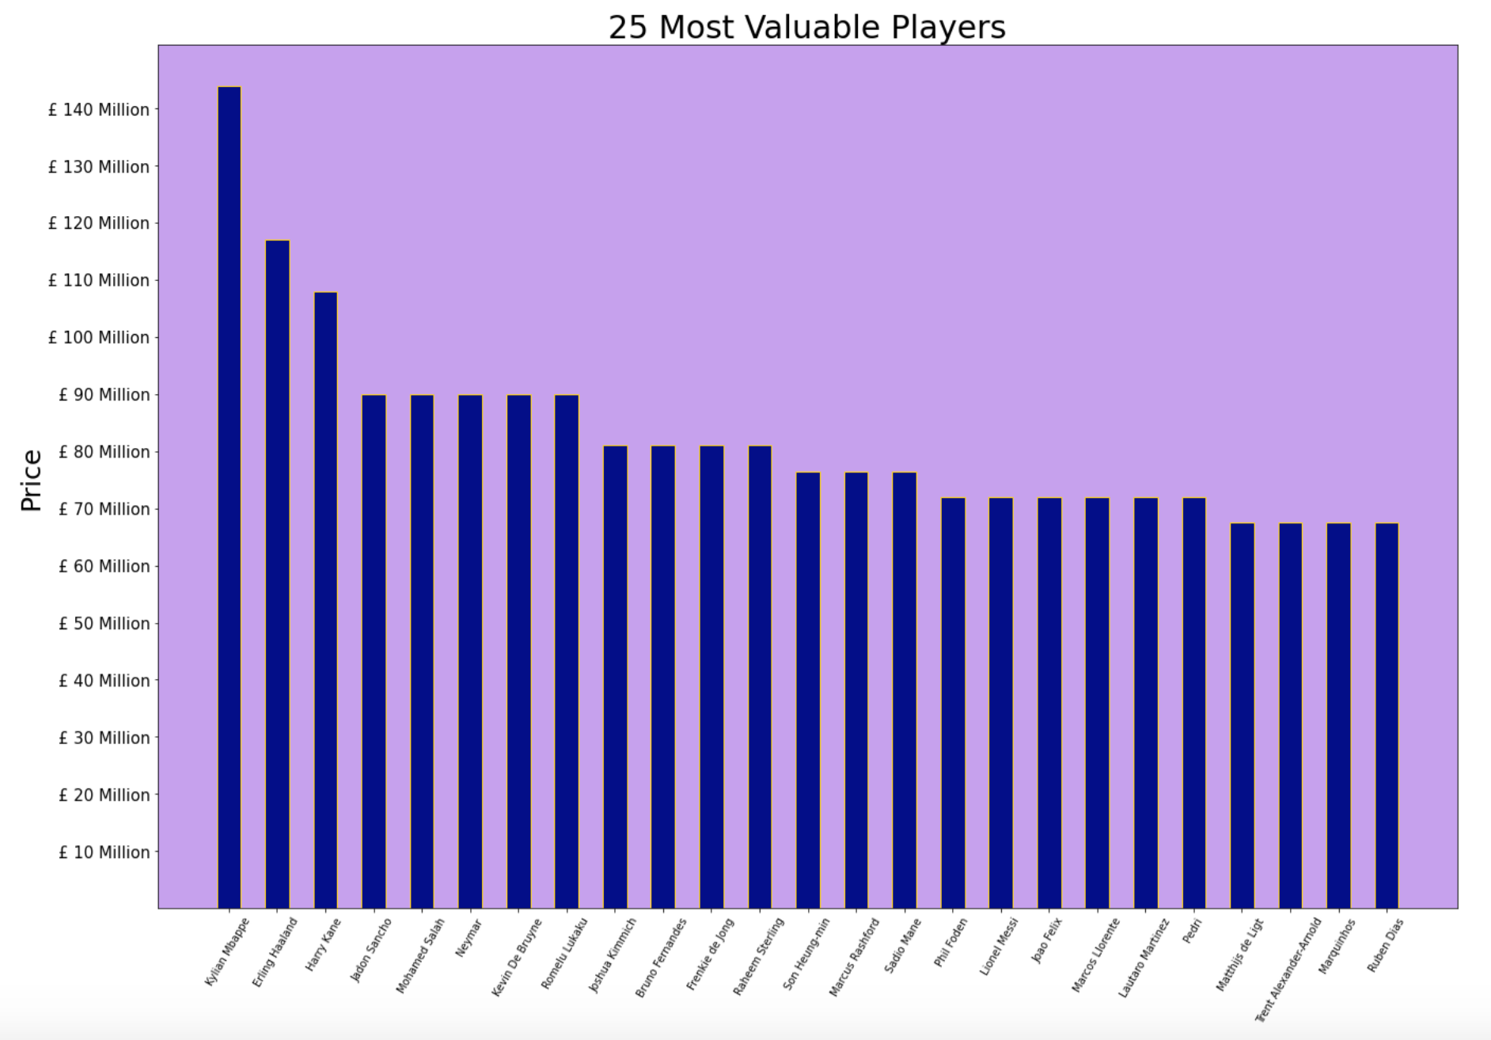
Figure 7.1 : Top 25 Most Valuable Players

7.2 Missing Value and Sparsity Assessment
Prior to feature engineering, a systematic assessment of missing values was conducted. Visual summaries of column-wise null percentages were used to identify features with extreme sparsity, particularly URL fields, image links, and auxiliary metadata. These features were removed as they did not contribute predictive value and introduced unnecessary noise.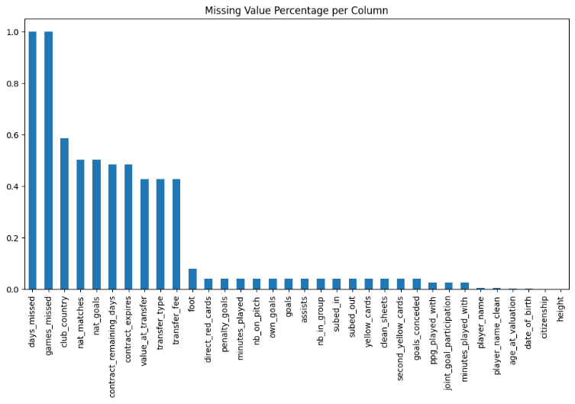Figure 7.2: Feature-wise Missing Value Distribution

7.3 Data Type and Temporal Consistency Checks
Several date and season fields originated from heterogeneous sources and appeared in multiple formats. Visual checks on date ranges and season coverage were used to verify successful normalization into a unified datetime format. This ensured that derived features such as age, contract duration, and transfer recency were computed accurately.

7.4 Outcome of Preprocessing
By combining programmatic cleaning with visual validation, the preprocessing phase ensured that:
- Irrelevant and sparse features were removed
- Numerical fields were stable and consistent
- Temporal attributes were standardized
- Market structure and player hierarchy were preserved
This stage established a clean and trustworthy dataset, ready for feature transformation and modeling.

8. Feature Engineering and Normalization
Feature engineering was treated as a translation layer between raw football data and real-world valuation logic. Instead of maximizing feature count, the objective was to extract signals that directly influence how clubs, agents, and analysts assess player value.

8.1 Performance Normalization and Trend Capture
Raw performance metrics were normalized using per-90-minute calculations to account for differences in playing time. Visual comparisons between cumulative goals and goals per 90 minutes demonstrated how normalization prevents bias toward players with higher minutes played.
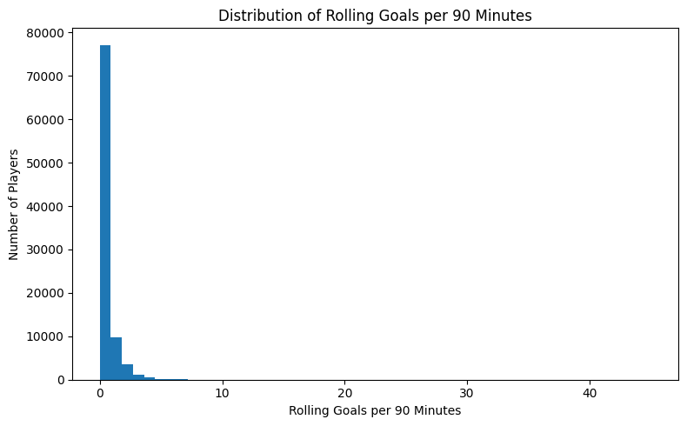
Figure 8.1: Cumulative Goals vs Goals per 90 Minutes

8.2 Injury Risk Feature Validation
Injury history was transformed into availability and risk indicators, such as total days missed and injury frequency. Distribution plots of injury-related features were used to ensure realistic separation between injury-prone and consistently available players.
These visual checks validated that injury features capture risk without disproportionately penalizing players with minor or short-term injuries.

8.3 Contract and Transfer Dynamics
Contract duration, age, and transfer recency were engineered as economic signals. Scatter plots comparing age and market value, as well as time since last transfer and valuation, were used to confirm expected market behavior.
These visuals ensured that engineered features aligned with real-world football economics, such as declining value with age and increased valuation following recent high-profile transfers.

8.4 Sentiment Feature Integration
Sentiment features were aggregated at the player level and treated as contextual modifiers. Visualizations comparing sentiment score distributions against market value confirmed that sentiment acts as a secondary influence rather than a dominant driver.
This reinforced the design choice to include sentiment as a complementary signal.
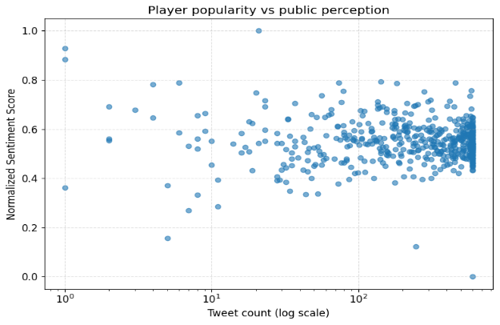
Figure 8.2 : Sentiment Score Distribution Across Market Value Segments
To address heavy right-skew in financial features, logarithmic transformations were applied. Side-by-side distribution plots before and after transformation were used to confirm variance stabilization and reduced outlier dominance.
These transformations ensured smoother learning behavior for both linear and ensemble models.

8.5 Outcome of Feature Engineering
Through iterative feature construction and visualization-based validation, the engineered feature set successfully:
- Removed playing-time bias
- Captured recent performance momentum
- Quantified injury and availability risk
- Modeled contract and transfer economics
- Incorporated sentiment without overpowering core signals
- Ensured numerical stability across models
This feature space formed a robust foundation for model training and selection.
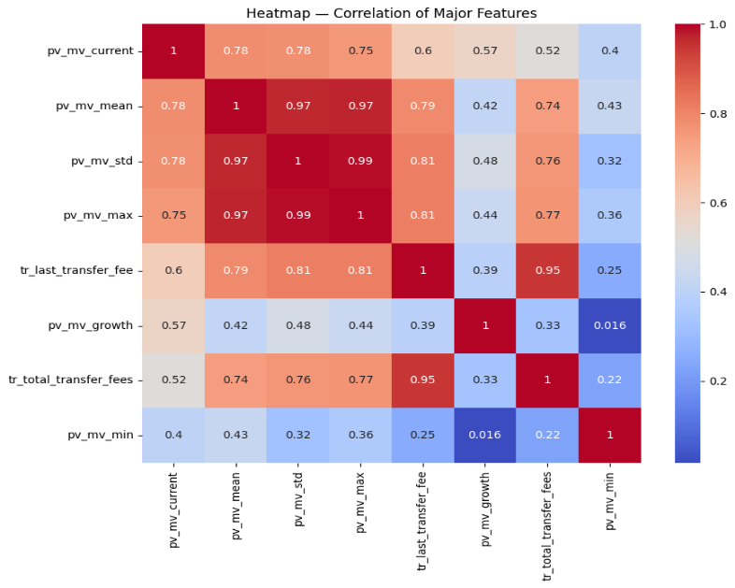
Figure 8.3: Feature Categories and Their Role in Market Value Prediction

9. Data Integrity and Leakage Prevention
Ensuring that the model’s performance would hold in real-world deployment required strict control over data integrity and information flow. One of the most critical risks addressed at this stage was target leakage.
Any feature that directly or indirectly encoded the target variable was deliberately excluded from the feature set. This included current market value indicators or transformations derived from it. Only historical trends and independent attributes were retained, ensuring that the model learned genuine relationships rather than memorizing disguised target information.
High-cardinality categorical features posed another challenge. Entities such as player identities, clubs, and nationalities contain valuable contextual information but are unsuitable for naive encoding strategies. One-hot encoding was avoided due to scalability concerns and the risk of overfitting. Instead, a cross-validated target encoding approach was adopted, allowing the system to capture category-level valuation patterns while maintaining strict separation between training and validation data.
This combination of leakage controls and encoding discipline ensured that validation metrics remained trustworthy and reflective of true predictive capability.

10. Outlier Handling and Data Robustness
The football transfer market naturally exhibits extreme values, particularly among elite players. Removing these records would have distorted the market representation and reduced the model’s practical relevance. Instead, the system was designed to handle outliers in a controlled and principled manner.Outlier behavior was analyzed across financial and performance-related features. Rather than filtering records, transformations were applied to compress extreme scales while preserving relative ordering. Logarithmic scaling played a central role in this process, significantly reducing skewness and stabilizing learning dynamics.
In cases where extreme values still posed a risk to numerical stability, capping strategies were applied to limit their influence without discarding the underlying data. This approach allowed the model to learn from high-value players while preventing them from dominating training behavior.
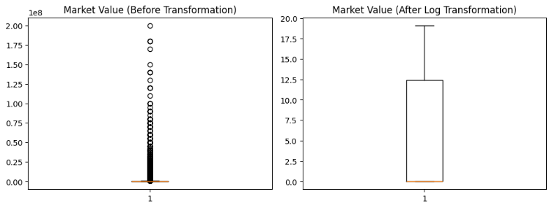
Fig 10.1 . Outlier analysis

11. Modeling Strategy and Evaluation Framework
Model development followed a progressive and evidence-driven approach. Instead of immediately adopting complex algorithms, simpler models were used to establish baselines and reveal structural limitations in the data representation.
Linear models provided an initial reference point but struggled to capture the non-linear relationships inherent in player valuation. Regularization improved stability but did not resolve these structural constraints. Tree-based models introduced interaction learning, significantly improving performance by capturing relationships between performance, availability, and market exposure.
Throughout this process, models were evaluated not only on numerical accuracy but also on behavioral stability. Training and validation performance were continuously monitored to detect overfitting. Visual diagnostics played a central role in this assessment, revealing whether improvements reflected genuine learning or dataset artifacts.
This evaluation framework ensured that the final model choice was justified through observed behavior rather than assumed superiority.
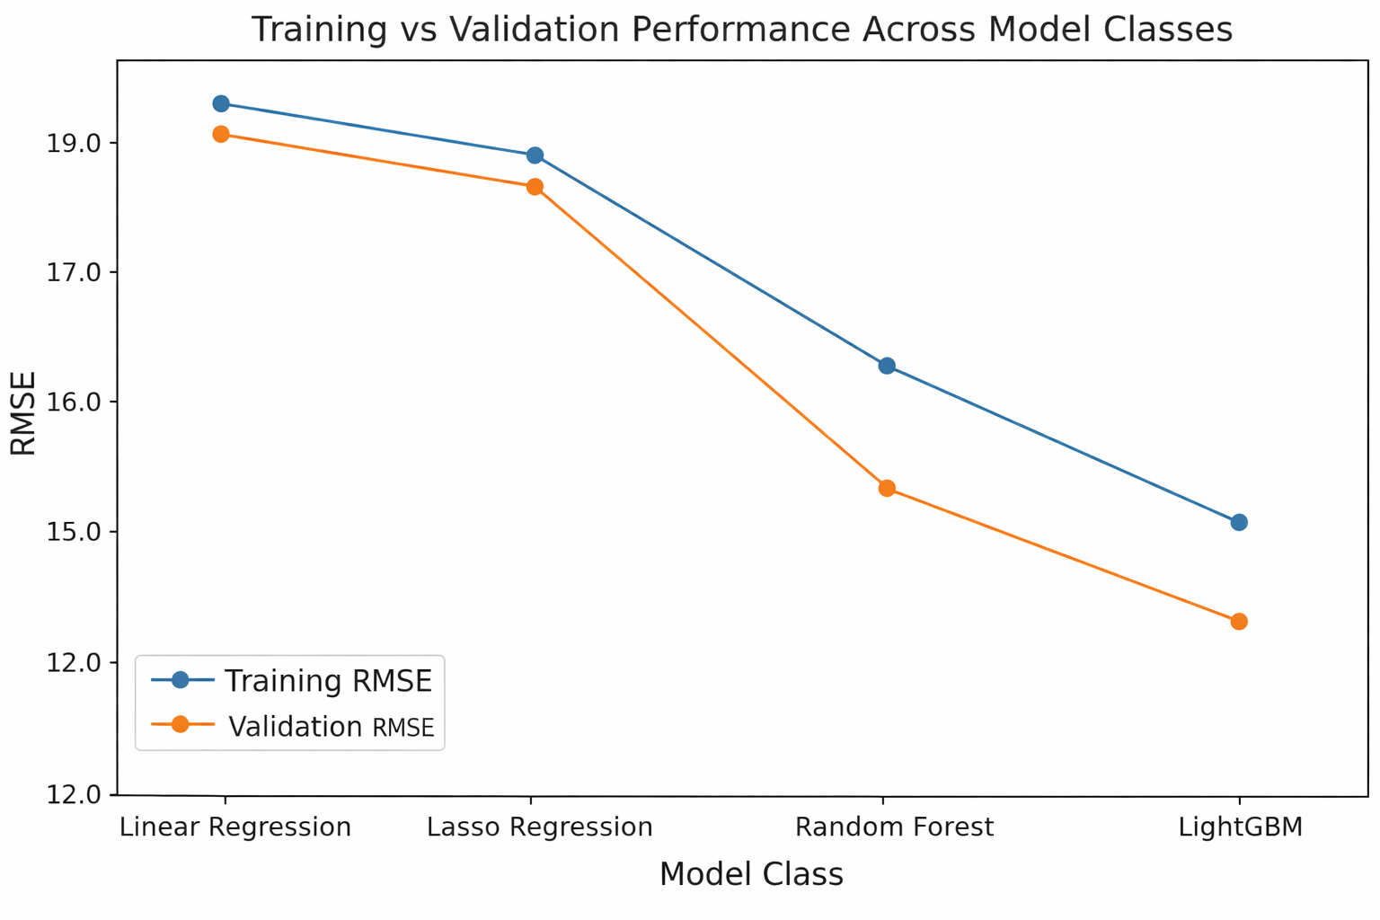
Figure 11.1 : Training vs Validation Performance Across Model
From figure it is clear that LightGBM has the :
- Lowest validation RMSE among all models
- Training and validation curves remain close and parallel

12. Final Model Selection
The final model selection was driven by a balance between predictive accuracy, stability, and deployment readiness. While ensemble models demonstrated strong performance, gradient boosting consistently exhibited superior generalization behavior.
LightGBM was selected as the final production model due to its ability to capture complex non-linear relationships while maintaining controlled learning dynamics. Its compatibility with target-encoded features and robustness to mixed feature scales made it particularly well-suited for the engineered feature space.
Validation results confirmed stable convergence, low bias, and strong performance across both average and high-value players. This consistency, combined with efficient training and inference characteristics, made LightGBM the most reliable choice for a production-grade valuation system.
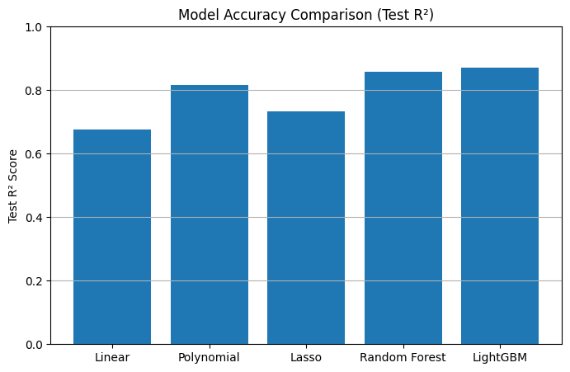
Fig 12.1 Model Accuracy Comparison

13. Model Validation and System Behavior
Before moving the system into a deployable state, the final model was subjected to a comprehensive validation process focused on understanding real-world behavior rather than maximizing offline metrics alone. Validation was treated as a quality gate to confirm that the system behaves predictably under realistic conditions.
The training and validation learning curves were closely monitored throughout the model development cycle. Stable convergence across both datasets indicated that the model was learning generalizable patterns rather than memorizing training data. No significant divergence between training and validation error was observed, reducing the risk of overfitting in production.
Prediction quality was further assessed through behavioral diagnostics. Actual versus predicted value plots showed strong alignment across the full valuation range, including elite players, which is critical for practical transfer-market use. Residual analysis revealed error distributions centered around zero with no systematic bias, confirming that the model does not consistently overestimate or underestimate player value in specific segments.
This validation phase confirmed that the model is not only accurate but also stable, predictable, and suitable for downstream deployment.
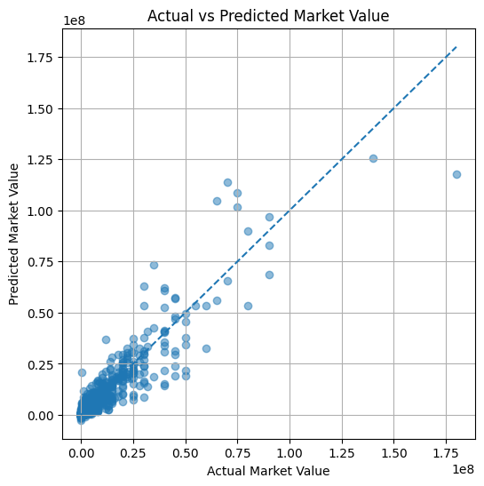
Figure 13.1 : Actual vs Predicted Market Value (Final Model)

14. Model Interpretability and Trust Layer
For a valuation system to be trusted by stakeholders, its predictions must be explainable. Given the complexity of the final model, interpretability was treated as a core system requirement rather than an optional enhancement.
The system incorporates SHAP-based explanations to expose how individual features contribute to predictions. At a global level, this allows stakeholders to understand which categories of information—such as recent performance trends, market exposure, or injury history—drive valuation decisions. Importantly, the model does not rely on any single feature, indicating a balanced decision-making process.
At the individual prediction level, SHAP explanations enable traceability. For any player valuation, the system can clearly communicate why the predicted value increased or decreased relative to the baseline. This capability is essential for building trust with non-technical users and aligning model outputs with football domain expertise.
The interpretability layer transforms the model from a black-box predictor into a transparent decision-support system.
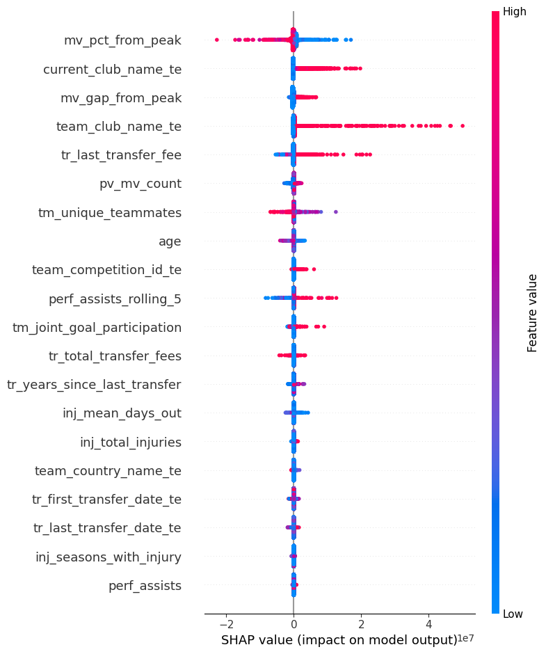
Figure 14.1: SHAP Global Feature Contribution Summary

15. Deployment Architecture and Inference Pipeline
The transition from experimentation to production required a deployment architecture that guarantees consistency, reliability, and ease of use. The system was designed with a clear separation between training logic and inference logic to prevent discrepancies between offline evaluation and real-time predictions.
The trained model and all preprocessing components were serialized and versioned together. This ensures that every prediction request uses the same transformations and feature ordering as the training environment. By preserving the full preprocessing pipeline, the system eliminates training–serving skew, a common failure point in deployed machine learning systems.
A web-based interface was implemented to expose the model’s functionality to end users. The interface accepts player-related inputs, applies the standardized preprocessing pipeline, performs inference using the serialized model, and returns predicted market values in real time. This setup allows both technical and non-technical users to interact with the system without requiring direct access to the underlying model.
The inference pipeline is deterministic, repeatable, and designed to support future integration with external systems through APIs.
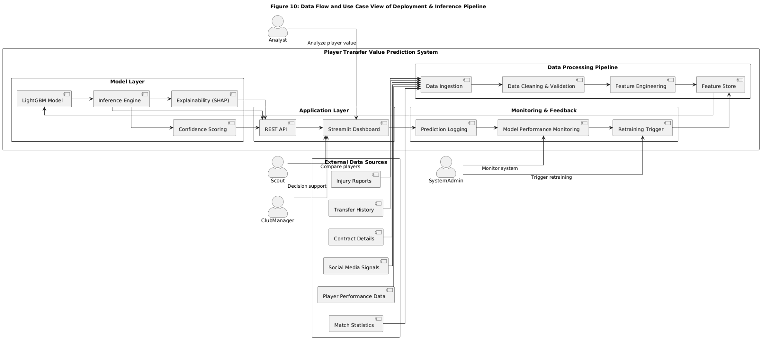
Figure 15.1 : Deployment Architecture and Inference Pipeline Flow
Figure 15.1 illustrates a hybrid Data Flow and Use Case view of the deployed player transfer value prediction system. It highlights how multi-source football data flows through preprocessing and modeling stages, while also capturing user interactions with the deployed Streamlit application and the system’s monitoring and retraining feedback loop.

16. System Limitations and Risk Considerations
Despite strong performance and stability, the system has clearly defined operational boundaries. Predictions for players with limited historical data or minimal market exposure may be less reliable due to insufficient signal availability. Similarly, sentiment-based features can be noisy for players with low public visibility, and their influence is intentionally constrained within the model.
The system is also trained on historical data and may exhibit a delay in reflecting sudden market shocks such as unexpected transfers or major injuries. These scenarios represent natural limitations of any data-driven predictive system operating in a dynamic market.
Acknowledging these constraints ensures responsible usage and sets appropriate expectations for stakeholders relying on the system’s outputs.

17. Monitoring, Maintenance, and Model Lifecycle Management
The valuation system is designed as a living product rather than a static artifact. To maintain accuracy over time, a monitoring framework was defined to track model performance and data behavior after deployment.
Prediction accuracy is periodically evaluated using newly available transfer and performance data. In parallel, feature distributions are monitored to detect shifts in player characteristics or market dynamics. Sustained degradation in performance or significant distribution changes trigger a retraining cycle.
This lifecycle management strategy ensures that the system evolves alongside the football market and remains relevant across seasons and transfer windows. By formalizing retraining triggers and monitoring criteria, the system avoids ad-hoc updates and maintains long-term reliability.

18. Final Outcome and Business Impact
This project successfully delivered a production-ready machine learning system for football player market value prediction, designed to operate reliably in real-world decision-making environments. The solution integrates data from multiple heterogeneous sources, applies robust feature engineering and leakage-safe modeling practices, and provides transparent, explainable predictions through an accessible user interface.
From a model performance perspective, the final LightGBM model demonstrated strong accuracy and generalization. The system achieved a training R² of 98.2% and a validation R² of 86.9%, indicating that the model captures the majority of variance in player market values while maintaining stable performance on unseen data. The corresponding error metrics further validate this behavior, with a training RMSE of approximately 0.50 million and a validation RMSE of approximately 1.33 million, reflecting controlled generalization without significant overfitting. These results confirm that the model effectively balances learning capacity and robustness, making it suitable for deployment rather than offline experimentation.
From a business perspective, the system reduces subjectivity in player valuation by providing consistent, data-driven estimates that incorporate performance trends, injury risk, contract dynamics, transfer history, and public perception. This enables more informed decision-making in transfer negotiations, contract planning, and market analysis. The architecture is designed to scale, allowing the framework to be extended to additional leagues, seasons, or analytical objectives with minimal structural changes.
From an engineering perspective, the project demonstrates industry best practices across the full machine learning lifecycle. This includes rigorous data integrity checks, strict target leakage prevention, interpretable model outputs through SHAP, and a deployment-ready inference pipeline that ensures consistency between training and production environments. Monitoring and retraining strategies further ensure long-term system reliability.
Overall, the outcome is a practical, trustworthy, and maintainable valuation system that successfully bridges advanced machine learning techniques with real-world football analytics and business needs.

19. Future Enhancements
Future iterations of the system can extend its capabilities by incorporating confidence scoring for predictions, enabling users to understand uncertainty alongside value estimates. Additional data sources such as scouting reports or advanced tracking metrics could further enhance model accuracy, particularly for emerging players.
Improvements to the sentiment analysis module using more advanced natural language processing techniques may also reduce noise and increase robustness. These enhancements can be integrated within the existing architecture without fundamental redesign, highlighting the flexibility of the system.

